Order Of Lenten Service

Opening Hymn: TLH 157

Reading: Lent IV

The History of the Passion of our Lord

Sermon Hymn: TLH 158

Sermon Text: Luke 20:27-40

Moses At The Bush

Confession of Sins: O almighty God, merciful Father, I, a poor miserable sinner, confess unto Thee all my sins and iniquities, with which I have ever offended Thee and justly deserved Thy temporal and eternal punishment. But I am heartily sorry for them and sincerely repent of them, and I pray Thee of Thy boundless mercy and for the sake of the holy, innocent, bitter sufferings and death of Thy beloved Son, Jesus Christ, to be gracious and merciful to me, a poor, sinful being.

Holy Communion

The Lord's Prayer

The Blessing

Closing Hymn: TLH 159

* * * * * * * * * * * * *

Bible Study: Lambs: Volcano
Sheep: Deuteronomy 2:1-15
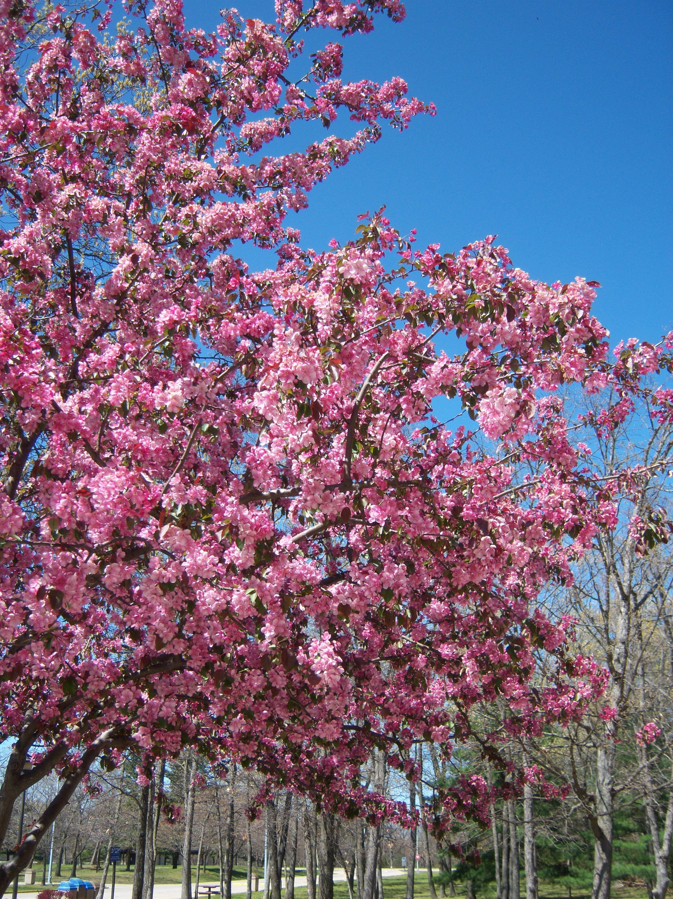

Spring In Minnesota

Water
Of
Life

12 March 2023

W A T E R O F L I F E

Independent Christian Church—Conservative Lutheran Doctrine

Worship Service: 9:30 a.m. Bible Study: 10:45 a.m.

Larry Cooper, Pastor E-Mail address:
lcooper@wateroflife.cc
Web Site:
www.wateroflife.cc

* * * * * * * * * * * * * * * * * * * * * * * * * * *

Sermon Text: Luke 20:27-40

Moses At The Bush

* * * * * * * * * * * * * * * * * * * * * * * * * * *

27 Then came to him certain of the Sadducees, which deny that there is any resurrection; and they asked him,
28 Saying, Master, Moses wrote unto us, If any man's brother die, having a wife, and he die without children, that his brother should take his wife, and raise up seed unto his brother.
29 There were therefore seven brethren: and the first took a wife, and died without children.
30 And the second took her to wife, and he died childless.
31 And the third took her; and in like manner the seven also: and they left no children, and died.
32 Last of all the woman died also.

33 Therefore in the resurrection whose wife of them is she? for seven had her to wife.
34 And Jesus answering said unto them, The children of this world marry, and are given in marriage:
35 But they which shall be accounted worthy to obtain that world, and the resurrection from the dead, neither marry, nor are given in marriage:
36 Neither can they die any more: for they are equal unto the angels; and are the children of God, being the children of the resurrection.
37 Now that the dead are raised, even Moses shewed at the bush, when he calleth the Lord the God of Abraham, and the God of Isaac, and the God of Jacob.
38 For he is not a God of the dead, but of the living: for all live unto him.
39 Then certain of the scribes answering said, Master, thou hast well said.
40 And after that they durst not ask him any question at all.

